**Physiology 115 Name ______________________________**Spring 2015

**FINAL**

For the multiple choice questions, there is *one* and *only one* best answer. READ THE OPTIONS CAREFULLY: multiple choice questions are formatted to reduce paper use and it can possibly be more troubling to comprehend options properly.

1. The 40S ribosome subunit is part of a complex that attaches to the m7G cap on the 5’ end of messenger RNA (mRNA). In what biological process does this happen?
   1. prophase of meiosis I (b) metaphase of meiosis I (c) transcriptional initiation  
      (d) translational initiation (e) translational elongation
2. Which of the below are part of contained within pre-mRNA but NOT part of mRNA and will be spliced out?
   1. promoter (b) transcription factors (c) poly(A) tail on 3’ end (d) exon (e) intron
3. What kind of chemical bond is responsible for base pairing in creating double stranded DNA?
   1. ionic bond (b) promoter bond (c) hydrogen bond (d) covalent bond (e) intron bond
4. Why are there cristae in the mitochondria?
   1. to break down more glucose to pyruvate   
      (b) so that catalase can get access to hydrogen peroxide (H2O2)  
      (c) so the vesicles can walk down microtubules   
      (d) to help more lactate form  
      (e) to increase the surface area for more electron transport system reactions and ATP production
5. A lysosome fused with a phagocytic vesicle. Which of these is TRUE?
   1. the lysosome contain proteins and other molecules that have digestive properties or chemical reactions that break down what is in the phagocytic vesicle
   2. the resulting vesicle has membrane protein transporters that are proton (H+) ATPases and will move H+ from the cytosol into the vesicle
   3. the pH within the vesicle will decrease
   4. both (a) and (b)
   5. all of the above are true
6. This kind of membrane protein is a classical example of one that binds to growth factor ligands on the extracellular domain, pairs with an identical membrane protein subunit, then undergoes autophosphorylation on intracellular domain before being activated to phosphorylate other proteins
   1. receptor tyrosine kinases (b) G protein-coupled receptors (c) steroid hormone receptors  
      (d) sodium (Na)/glucose transporter (e) DNA polymerase I
7. A **connexon** is a principal feature of which type of cell junction?
   1. adherens junction (b) desmosome (c) gap junction (d) nuclear pore (e) tight junction
8. The onset of the breakdown of the nuclear envelope signals what phase of mitosis?
   1. prophase (b) prometaphase (c) metaphase (d) anaphase (e) telophase
9. What is a term for the process when the tRNA in the P site of the ribosome passes the long nascent polypeptide to the single amino acid on the tRNA in the A site?
   1. transcription (b) replication (c) decoding (d) translocation (e) transpeptidation
10. DNA polymerase III needs what to happen before it can start adding nucleotides during replication?
    1. It needs transcription factors to bind to the promoter (b) It needs RNA polymerase to make mRNA  
       (c) RNA primers must be present (d) exons must be spliced out (e) 5’🡪3’ intron synthesis is required
11. Which of these describes substrate level phosphorylation?
    1. ATP is produced by proton (H+) gradients across mitochondrial inner membrane in electron transport
    2. ATP is produced from a reaction in glycolysis or the TCA cycle
    3. GTP is used to move ribosome during translation the distance of one codon or 3 nucleotides
    4. ATP is used to move vesicles along a microtubule
    5. ATP is produced during ribosome assembly in the nucleus
12. A genome has 20% T. Which of the following is TRUE?
    1. it has 20% C (b) it has 30% A (c) the sum of the purine content is 50%   
       (d) %C + %T = 40% (e) none of the above is true
13. This structure for coiling DNA about twice around a core set of histones is called
    1. solenoid (b) chromatid (c) chromosome (d) centriole (e) nucleosome
14. At the molecular level, this represents the many variations in the DNA sequences of a gene that show up as a variation in the trait corresponding to that gene
    1. intron (b) exon (c) genome (d) allele (e) locus
15. Oligonucleotide A has a higher melting temperature (Tm) than oligonucleotide B, and both have the same length (same number of base pairs). Which of these is clearly understood to be true?
    1. %AT content of oligo A is higher than oligo B   
       (b) the absorbance at 260 nm of oligo A will not increase as temperature goes up  
       (c) %GC content of oligo B is lower than that of oligo A  
       (d) the melting of oligo B is all about renaturation: forming double-stranded DNA from two single strands
16. Which of these is NOT a feature of the Golgi apparatus?
    1. it has a *trans* face that receives vesicles from the endoplasmic reticulum (ER)
    2. everything starts with vesicle fusion to the *cis* face of the Golgi
    3. it has cisternae like the endoplasmic reticulum also has cisternae
    4. lysosomes arise from vesicles formed in the Golgi
    5. glycoproteins get modified within the Golgi
17. Which of these is a feature found in DNA?

(a) 2’-deoxyribose (A) (b) uracil (U) (c) amino acid (d) ribose (e) adherens junction

1. The TCA cycle occurs where?

(a) mitochondrial inner membrane (b) mitochondrial intermembrane space   
(c) mitochondrial matrix (d) cytosol (e) peroxisome

1. In the smooth endoplasmic reticulum (SER) these are enzymes that metabolize toxic substances:
2. cytochrome P450 enzymes (b) ribosomes (c) RNA polymerases (d) cisternae (e) lamins
3. A steroid hormone passes directly through the phospholipid bilayer membrane from a high concentration to a low concentration without needing transport protein. What is this an example of?
4. simple passive diffusion (b) exocytosis (c) receptor-mediated endocytosis  
   (d) facilitated diffusion (e) coupled active transport
5. A vesicle comes off the *trans* face of the Golgi and makes its way to the plasma membrane without fusing with it, waiting for a signal so that fusion can occur to expel its contents exocytically. Which of the terms below describes this process?  
   (a) phagocytosis (b) simple passive diffusion (c) regulated secretion  
   (d) constitutive secretion (e) lysosomal formation
6. This enzyme makes messenger RNA (mRNA)

(a) RNA primase (b) ribosomal RNA (c) RNA ligase (d) RNA polymerase II (e) Na/K ATPase

1. Which of these RNA molecule types carries a single amino acid to the ribosome  
   during translation elongation?
2. messenger RNA (mRNA) (b) ribosomal RNA (rRNA) (c) promoter RNA (pRNA)  
   (d) transfer RNA (tRNA) (e) carrier RNA (cRNA)
3. How many bases (nucleotides) does an anticodon have?
4. 0 (b) 2 (c) 3 (d) 20 (e) 64
5. Which of these is FALSE with respect to the termination of eukaryotic translation?
6. it requires a protein called an eukaryotic release factor (eRF1)
7. a poly(A) tail will be added to the 3’ end of the messenger RNA
8. the ribosome A site must be positioned on a stop codon
9. the polypeptide will be released from the ribosome by a simple hydrolysis reaction
10. Which of these is FALSE with respect to the initiation of transcription?
11. it requires transcription factors
12. it requires promoters
13. DNA polymerase be used
14. RNA will be synthesized in the 5’🡪3’ direction
15. These are polymers of actin that form something called a terminal web
    1. intermediate filaments (b) desmosomes (c) microfilaments  
       (d) microtubules (e) protofilaments
16. Pyruvate is metabolized by the pyruvate dehydrogenase enzyme to form a 2-carbon product. Which of these is a FALSE statement about that reaction?
    1. CO2 is also a product (b) the 2-carbon product is acetyl-CoA (c) NADH is formed  
       (d) this reaction only happens when oxygen (O2) is available (e) the 2-carbon product is ethanol
17. FADH2 is *formed* in which of these metabolic processes?
    1. DNA replication (b) TCA cycle (c) glycolysis (d) lactate fermentation (e) electron transport
18. A single FADH2 molecule will produce how many ATP in the electron transport system?
    1. 1 (b) 2 (c) 3 (d) 32 (e) 38
19. What is the term for the physical location on the chromosome where a gene is found?
    1. allele (b) centromere (c) locus (d) genome (e) Golgi
20. Osmosis is the diffusion of what molecule or type of molecule?
    1. carbon dioxide (CO2) (b) water (H2O) (c) amino acids (d) lipids (e) carbohydrates

33. (a) Draw a simple diagram showing the mitochondrial inner membrane, intermembrane space, outer membrane and matrix. (b) Show which side NADH is on when it interacts with the electron transport system in the membrane. (c) Show how protons move across one of the parts of the mitochondria above and where the high concentration side of H+ is. (d) Show how ATP is formed.

1. How many ATP are formed from one NADH  
     
   (f) How many H+ are required to form one ATP molecule?

(g) Oxidative phosphorylation produces ATP from a concentration difference of ions moving across a membrane from high concentration to low concentration coupled to a membrane protein. Name any membrane protein learned that does the opposite and utilizes ATP to move ions from low concentration to high concentration (against their gradient)?

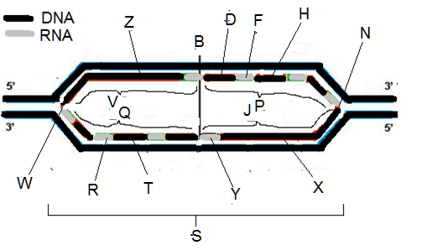

34. Above is a figure relevant to the replication of DNA showing DNA and RNA strands. There may be several possibilities for answers below in the diagram above. You only need enter one answer.

(a) ___ replication origin (b) ___ newly made DNA  
(c) ___ lagging strand (d)___ replication fork  
(e) ___ RNA primer (f) ___ replication bubble  
(g) ___ leading strand

35. (a) Nucleotides have 3 parts to their structure: name them *or* draw their structure  
  
  
(b) The 5 nitrogenous bases that make up are members of TWO classes of structures that begin with the letter “P.” (i) What is the name of the one class that has a chemical structure with two rings fused to each other, one pentagonal and the other hexagonal? (ii) Also write the one-letter symbol or the name of one nitrogenous base that is a member of it.  
  
  
(c) (i) What is the name of the other class with a single hexagonal ring as its chemical structure?  
(ii) Also write the one-letter symbol or the name of one nitrogenous base that is a member of it

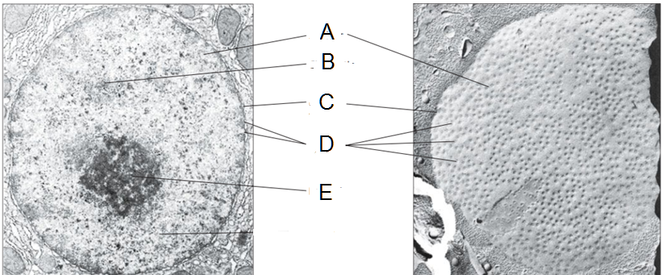  
  
36. The double-stranded DNA helix has different conformations. (a) What is the classic Watson-Crick conformation with the right-handed helical twist called? (b) what is the form of DNA called that has a zig-zag left-handed twist and is transcriptionally inactive?

37. The figure above is labeled with the fundamental parts of the nucleus, and a figure used in lecture. From the description below and using the labeled images above, write the NAME of the part of the nucleus. Item A is already labeled for you

A] ________________________ the organelle of the cell that contains its genome and is enclosed in  
two membranes and protects that genome from being altered by biochemical reactions occurring elsewhere in the cell

Nucleus

B] _______________________ this is the term given to the combination of DNA, RNA, and proteins that help to coil and manage the DNA making up genome  
(single 9-letter word)

C] _______________________ refers to the structure made of two membranes, inner and outer, with a perinuclear space in between (two words, total 15 letters)

D] _______________________ this is the term for a structure that has an annulus made up of an octameric protein through which all molecules like mRNA pass through to get in or out of nucleus (two words, total 12 letters, plural)

E] _______________________ this is a structural feature seen under the microscope where ribosomes are assembled from the proteins and ribosome RNA present in large amounts here, accounting for its special microscopic distinction from the nucleoplasm

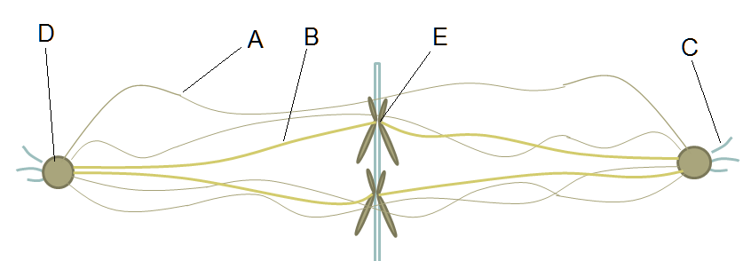38. The figure above is taken from the presentation on mitosis and specifically talks about the types of microtubules involved in mitosis

A] ________________________ This is the name of the microtubule in mitosis that connects one spindle pole with the other that pushes the poles apart (two words)

B] _______________________ This is the name of the microtubule in mitosis that connects spindle pole to chromosome (two words)

C] _______________________ This is the name of the microtubule in mitosis that connects spindle pole to the plasma membrane so that

D] _______________________ this is the 5-letter term for spindle pole that radiates out microtubules during mitosis

E] _______________________ this the 11-letter word for the structure that connects the centromere of the chromosome to the type of microtubule labeled B

F] What is the name of the structure that is located near the nucleus and which duplicates just before mitosis and migrates around the nucleus to form these spindle poles?

G] The structure that is F is composed of two of these that are oriented at right angles to each other and have a pinwheel array of 9 fused triplet formations of microtubules. What is the name of this thing that F has two of?

H] All these microtubules are made of two proteins: what are the names of these proteins?

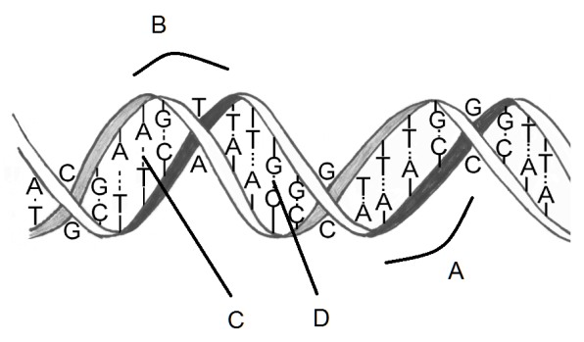39. (a) Give the name of part labeled A in the figure at the right  
  
(b) Give the name of part labeled B